**Summary of the research paper as an outcome of PBL-I project**

**ON**

**“CROWD COUNTING”**

Submitted in partial fulfillment of the requirements for the degree of

BACHELOR OF TECHNOLOGY in COMPUTER SCIENCE & ENGINEERING

Submitted By

HIMANI ARORA-22070122079

HIMANSHU CHOPADE-22070122080

UNDER THE GUIDANCE OF

Prof. Nilima Zade



**DEPARTMENT OF COMPUTER SCIENCE & ENGINEERING**

**Symbiosis Institute of Technology, Pune**

**Symbiosis International (Deemed University)**

**CERTIFICATE**

**DEPARTMENT OF COMPUTER SCIENCE & ENGINEERING**

**Symbiosis Institute of Technology, Pune**

**Symbiosis International (Deemed University)**

This is to certify that the PBL-I Project work entitled “**Crowd Counting**” is carried out by the **Himani Arora** and **Himanshu Chopade,** in partial fulfillment for the award of the degree of **Bachelor of Technology** in **Computer Science & Engineering**, Symbiosis Institute of Technology Pune, Symbiosis International (Deemed University) Pune, India during the academic year 2023-2024.

|  |  |  |
| --- | --- | --- |
|  |  | Dr. Nilima Zade |
|  |  | Name of Guide |
|  |  |  |
|  |  |  |
|  |  |  |
|  |  |  |
|  |  |  |

**UNDERTAKING**

We undertake that we have prepared a paper as per the following details during our PBL-I project. The paper has been submitted to the project guide.

Tentative title of the of the paper: **Crowd Counting**

Status of the paper publication: Draft prepared

Himani Arora (22070122079) Signature

Himanshu Chopade (22070122080) Signature

|  |  |  |
| --- | --- | --- |
|  |  | Dr.Nilima Zade |
|  |  | Name & Signature of the Guide |
|  |  |  |
|  |  |  |
|  |  |  |
|  |  |  |
|  |  |  |

## TABLE OF CONTENTS

|  |  |  |
| --- | --- | --- |
|  | | **Page** |
| **Certificate** | | i |
| **Undertaking** | | ii |
| **Table of Contents** | | iii |
|  | |  |
| 1 | Problem statement of the project | 1 |
| 2 | Abstract of the Paper | 2 |
| 3 | Summary of the Literature Review | 3 |
| 4 | Brief description of the methodology | 4 |
| 5 | Summary of results | 5 |

**Problem statement of the project**

The Crowd Management System is a state-of-the-art solution to the intricacies of watching and controlling crowds during large events. The number of public gatherings has significantly increased, thus making it necessary to have an accurate count of people and immediate feedback. However, conventional manual crowd counts not only tend to be wrong but also take too much time. This system monitors and manages crowds in a way that has never been seen before by taking advantage of such advanced technologies as computer vision, artificial intelligence (AI), and data analytics. Its complex algorithms for counting people use video feeds from different surveillance cameras installed across the venue. These algorithms utilize up-to-date techniques for detecting and tracking objects so as to give precise estimates on crowd size as well as density at any given moment even under difficult environmental conditions.

The Crowd Management System also improves event safety by using different functionalities. It can recognize possible dangers or questionable conduct like unapproved entry or crowd unrests and notify security staff about them. Besides, it generates heatmaps of crowd density that show visually where congestion is highest which allows those organizing events to take early actions in managing crowds. In addition, the Crowd Management System is very compatible with other event management solutions such as emergency communication platforms and access control systems.

**Abstract of the Paper**

With rapid proliferation of population globally and the increase in public meetings, putting better mechanisms for crowd control techniques in place and looking at them with regards to safety and well-being for members at such events was direly needed. One of the older crowd management techniques relied on manual counts, and consequently, this was bound to be error-prone and time-consuming in mobilizing personnel required. Today, however, modern times provide an opportunity for innovative solutions to make it possible to monitor and execute events effortlessly in real-time.

This technological revolution finds its first in line in crowd counting, which utilizes sophisticated algorithms to count the number of people in images or videos with high accuracy. With processed massive datasets and processing power for deep learning algorithms, high levels of accurate crowd counting and automation can be achieved, heralding new levels of real-time monitoring precision that were previously unattainable. Crowd counting technology promises much in a number of domains, including event planning, public safety protocols, and the optimization of transportation strategies.

The proposed Crowd Management System is to rid the underlying error involved in the counting of crowds through the facilitation of real-time monitoring, effective resource allocation, and heightened security measures. The project uses the available diverse datasets and the existing systems, wherein it tries to identify the best methodologies to use for its implementation. Its effectiveness and reliability can then be determined through the various algorithms' implementation and their results compared to literature available.

Motivated by public safety and gatherings, the project is far much better than conventional manual counting and gives a wider advancement in society through innovation

**Summary of the Literature Review**

The literature review involved 11 documents which were evaluated in detail. The articles were chosen from popular scientific journals and conference papers dealing with computer vision and artificial intelligence. Every paper was used to estimate different crowd counting methods’ effectiveness. For this assessment, authors’ algorithms were deeply examined regarding their architectural design as well as procedures for counting crowds adopted by them. Moreover, datasets employed during the evaluation were also considered; such as UCSD, ShanghaiTech (part A & B), UCF_CC_50%, UCF-QNRF (part A & B), JHU-CROWD++ (part I), WiderFace(Train). Additionally, each approach was described by positive points followed by some disadvantages that might hinder practical implementation of these techniques. The strengths were determined based on achieved accuracy in counting individuals correctly under various conditions like highly populated areas or sparsely populated ones coupled with performance over benchmark datasets created specifically for this purpose.

**Brief description of the methodology**

**1. Model selection and customization:**

YOLOv5 is the next step in the development of object detection technology, working with Ultralytics: "You Only Look Once version 5" with the emphasis on simplicity, speed, and accuracy.

**2. Data collection and pre-processing**

We used the WiderFace dataset for both training and evaluating our research endeavor. The WiderFace dataset is a representative benchmark for face detection, comprising many images annotated with bounding boxes for faces.

**3. Model training and evaluation**

Hereby, a custom YOLO model was trained on pre-trained weights for efficient convergence. We utilized pre-trained weights as a means to use learned features from a source task for efficient acceleration of learning towards our target task.

**4. Optimizations and improvements**

This has given space for model pruning and quantization techniques to explore ways in which the inference speed may be accelerated while the performance of the models is maintained.

**Summary of results**

We reached the peak of **87.7% accuracy**

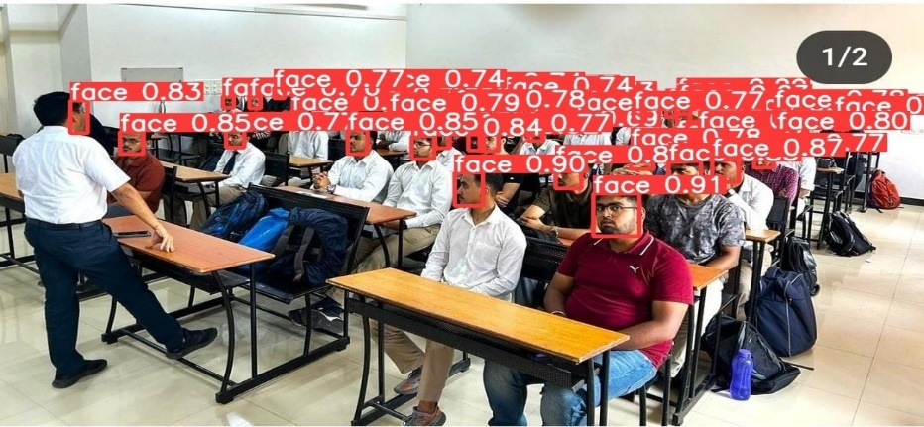

Count- 55 faces

Fusing layers...

Model summary: 157 layers, 7012822 parameters, 0 gradients, 15.8 GFLOPs

image 1/1 C:\Me\Crowd-Counting\yolov5\2.jpg: 480x640 **55 faces,** 130.3ms

Speed: 1.0ms pre-process, 130.3ms inference, 1.5ms NMS per image at shape (1, 3, 640, 640)

**Comparison against recent works on the wider** **faces dataset**

